# Gyroscope Test Plan

Test #1 – Adding Items

1. Fire up the application and you should see a window like this:

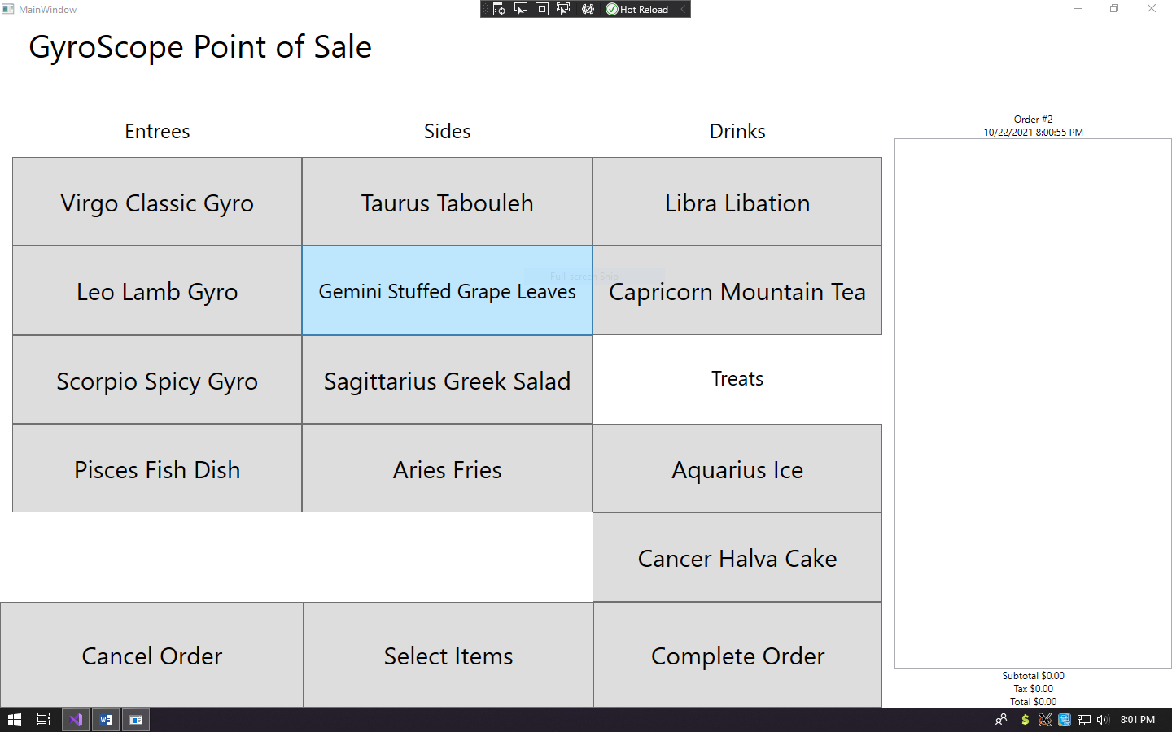

1. Click on the button the that says Virgo Classic Gyro and you should see a window like this:
   1. **Note: I clicked on the buttons to add or hold items from the gyro in the same step**
   2. **Note: the order number and the date show up to be the current time and date**

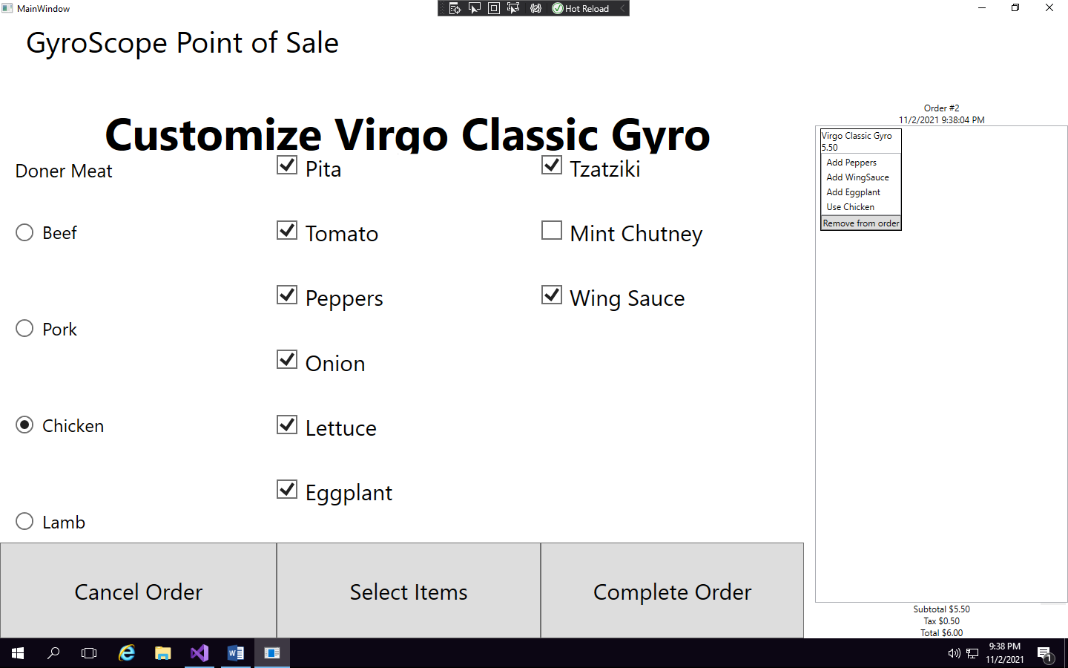

1. Lets just test another one of the button options to make sure it adds to the current order
   1. **Note: I clicked to add a Pisces Fish Dish just to show that the list view accounts for the changes**

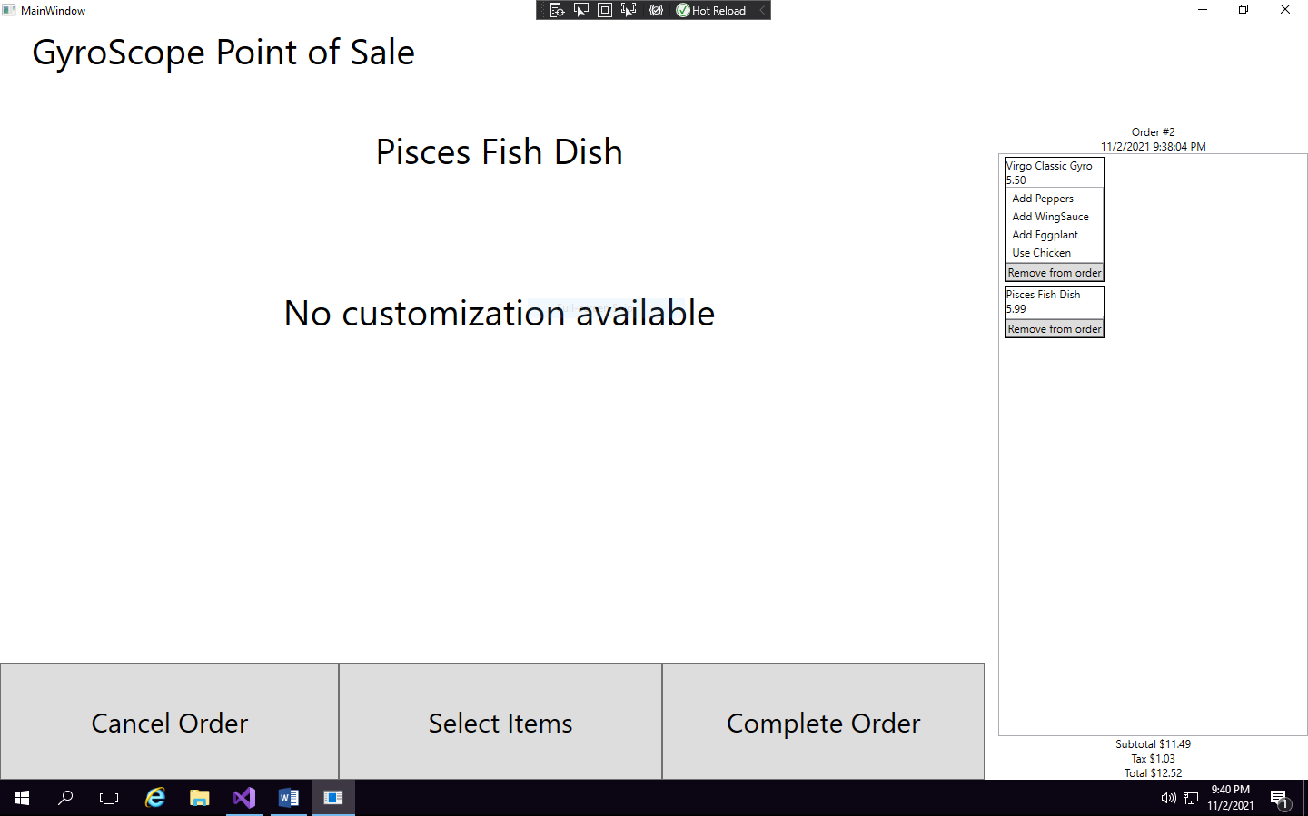

1. Once you add all the items you want in a specific order click the Complete Order button and it will come up with this screen
   1. **Note: I don’t test for the debit or credit buttons in this testing plan because all it shows is message boxes so it has minimal functionality**

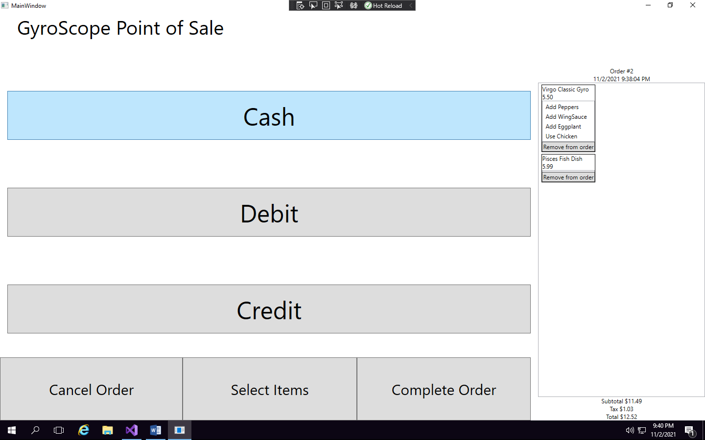

1. On the last step I clicked the cash button to bring up this screen
   1. **Note: I added a 20 since the total was $12.52 for the sake of this test**
      1. **Side-note: Amount Due doesn’t function properly**

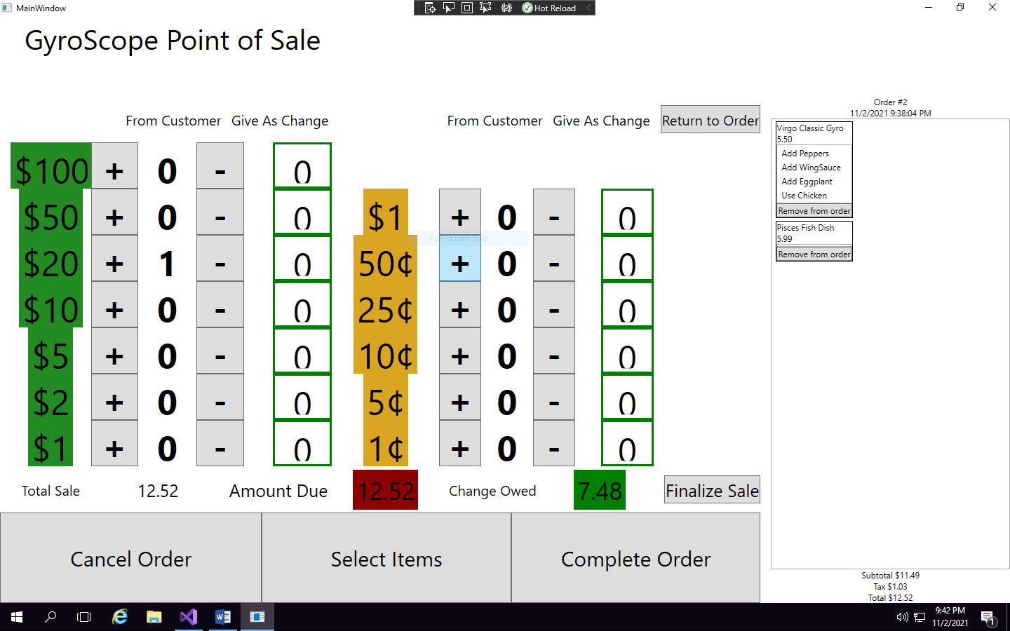

1. Add a 1-dollar cent to see the give as change label go up
   1. **Note: The dollar give as change labels don’t increment correctly**

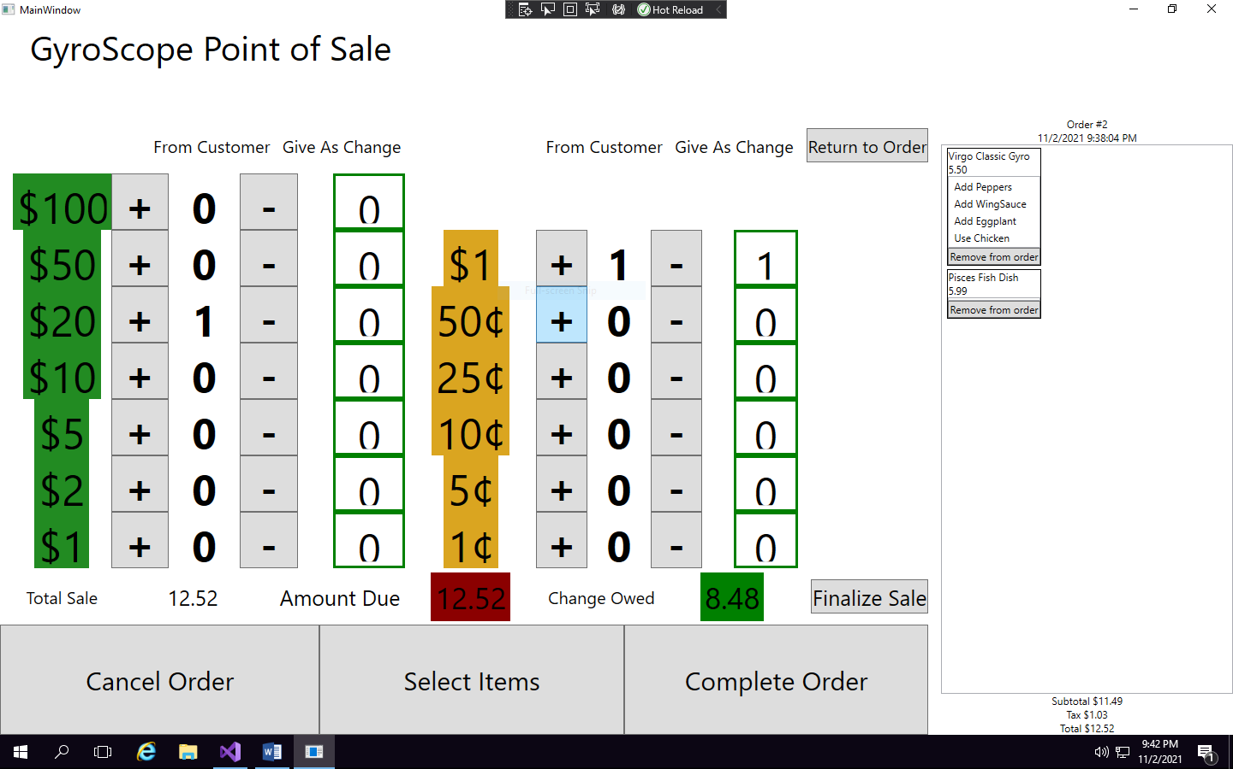

1. Click on the return to order button and a screen like this will show up
   1. **Note: The list view order is still the current order**

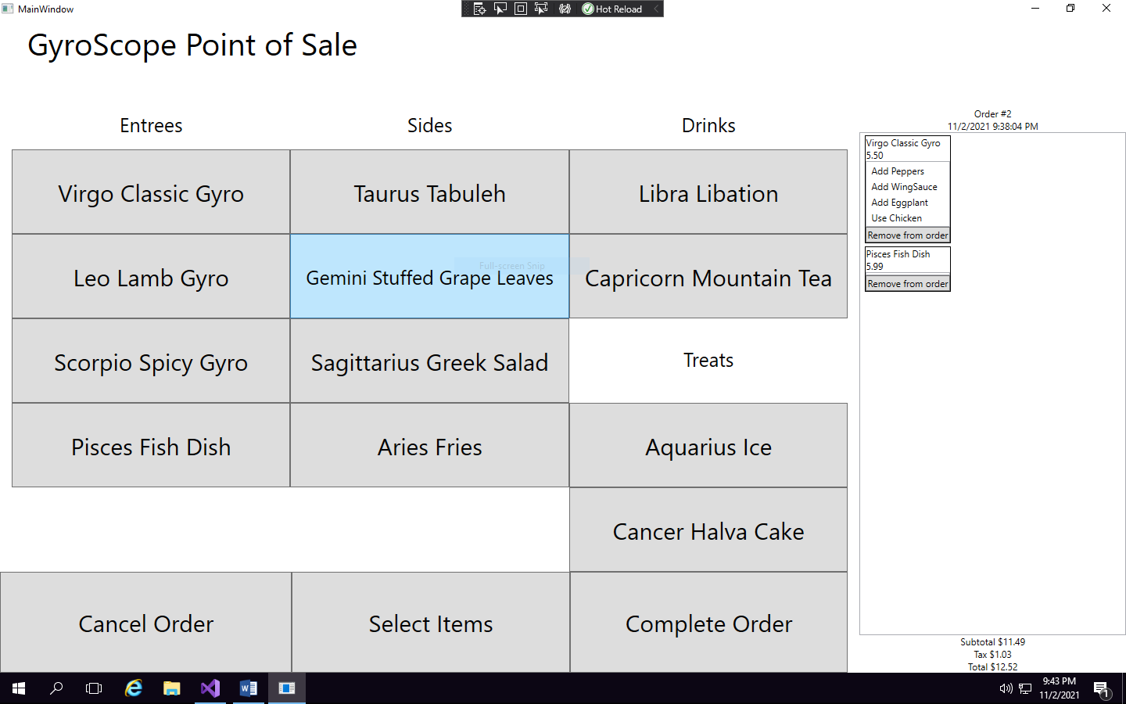

1. Click Complete Order and the Cash buttons again to get back to this screen

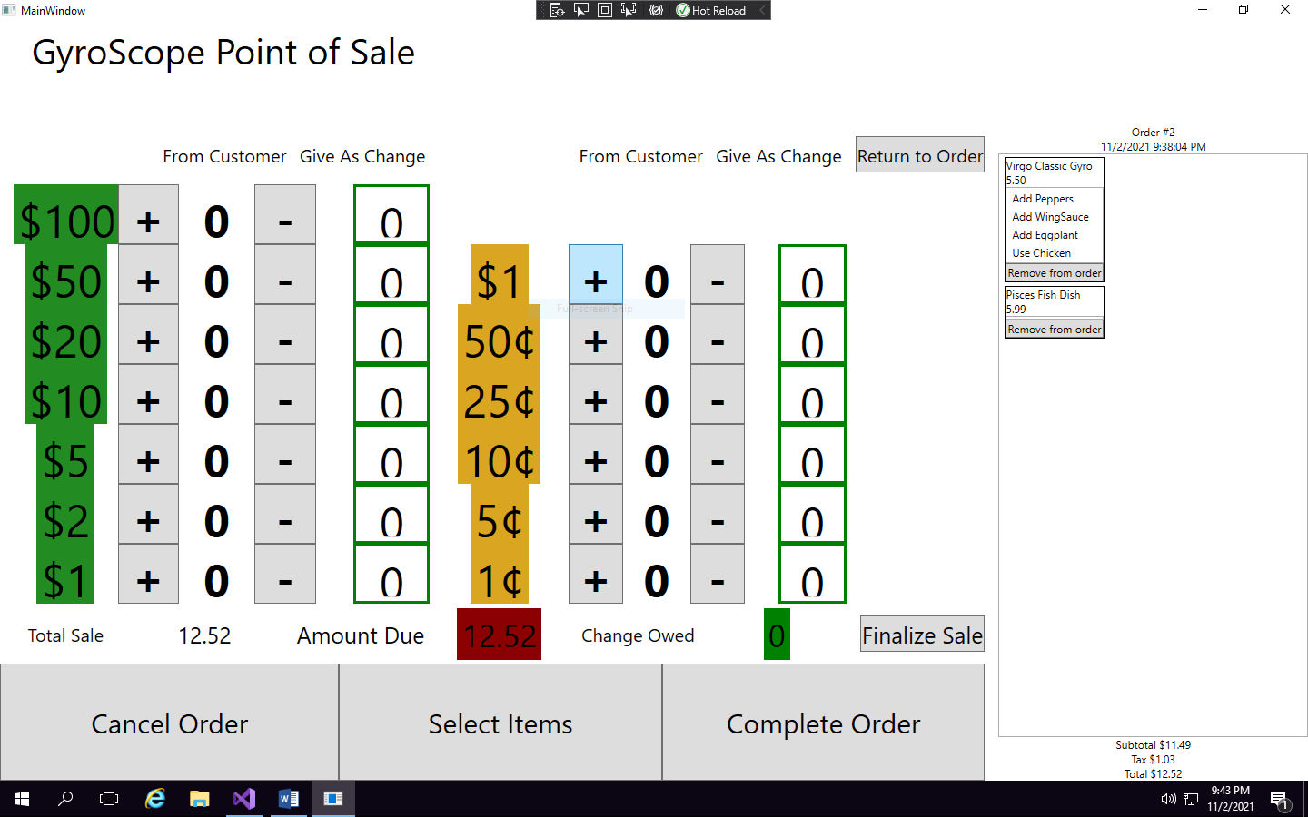

1. Click the Finalize Sale button and a screen like this should appear
   1. **Note: The list view and all of the order properties on the right side have been reset**

